**Computer Vision**

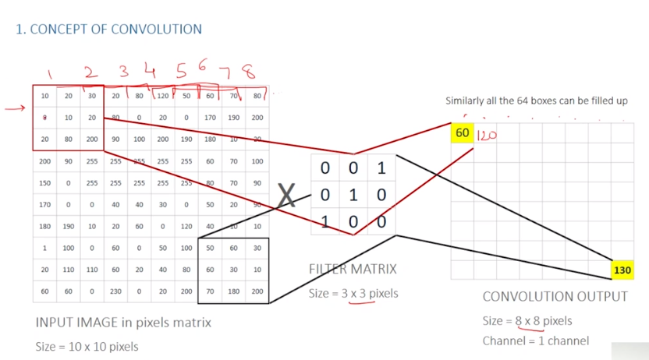

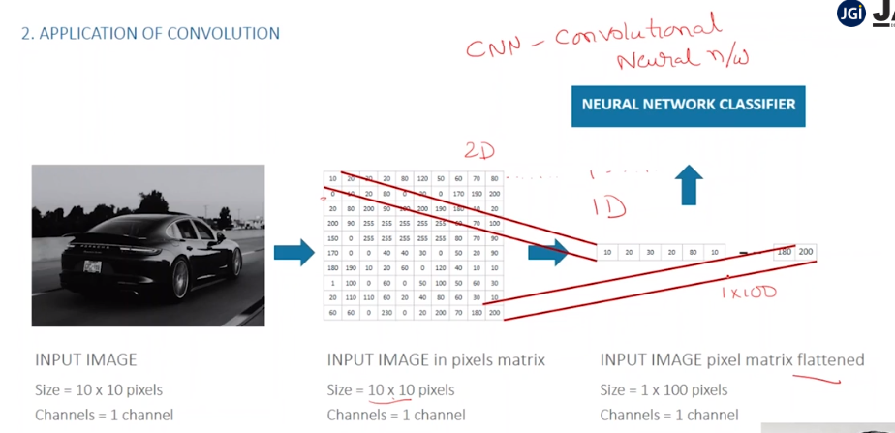

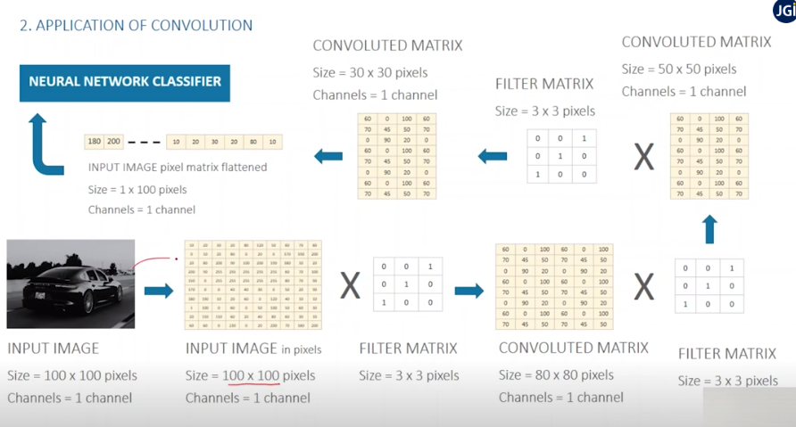

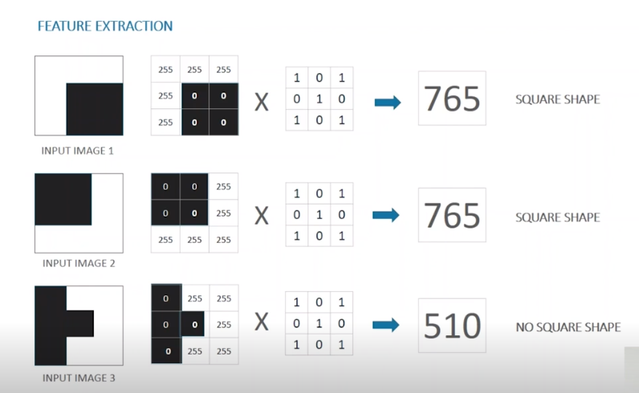

CONVOLUTION helps to extract unique features/characteristics from an image by producing a unique number as per the image pixels.

CONVOLUTION helps to reduce computation by reducing the dimension of the image which can be given as an input to simple neural networks to perform image classification.

**Summary**

“FEATURE EXTRACTION"

Convolution helps to extract pixel features from the images and use the same as an input to a simple neural network classifier reducing the size of computation to perform image classification.



